|  |  |
| --- | --- |
| **NAME** | Manvith BV |
| **REG NO** | 311520104031 |
| **TEAM ID** | NM2023TMID07074 |
| **EMAIL ID** | [Manvithbhoomi@gmail.com](mailto:Manvithbhoomi@gmail.com) |
|  | **ASSIGNMENT - 1** |

|  |  |
| --- | --- |
| **Task** | Upload the dataset to Cognos Analytics, delete the unnecessary columns, create a data module, explore and visualize the dataset |
| **Problem Statement:-** | |

The growth of supermarkets in most populated cities is increasing and market competitions are also high. The dataset is one of the historical sales of supermarket company which has recorded in 3 different branches for 3 months data. Predictive data analytics methods are easy to apply to this dataset.

**Output:-**

**Overall Dashboard**

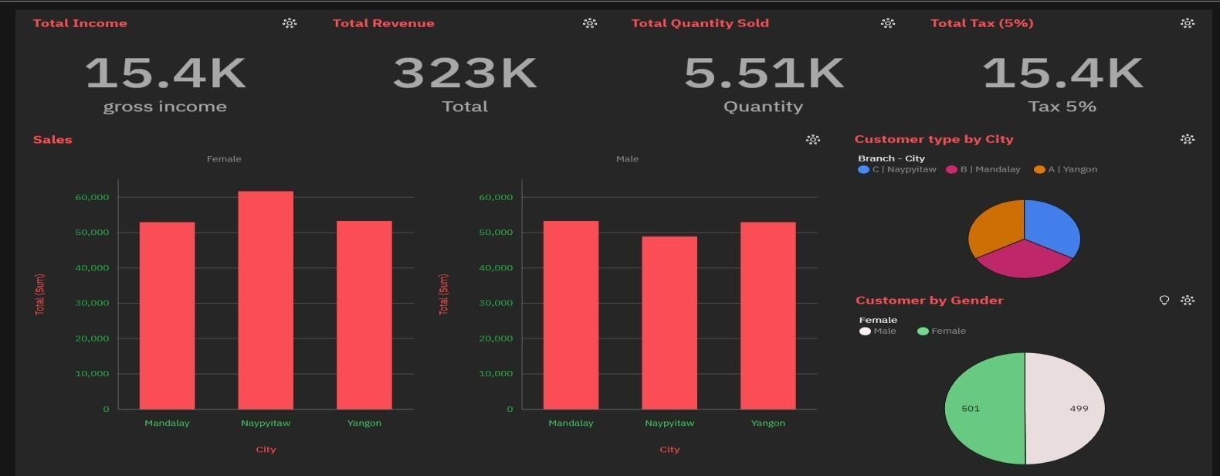

**Female Customers**

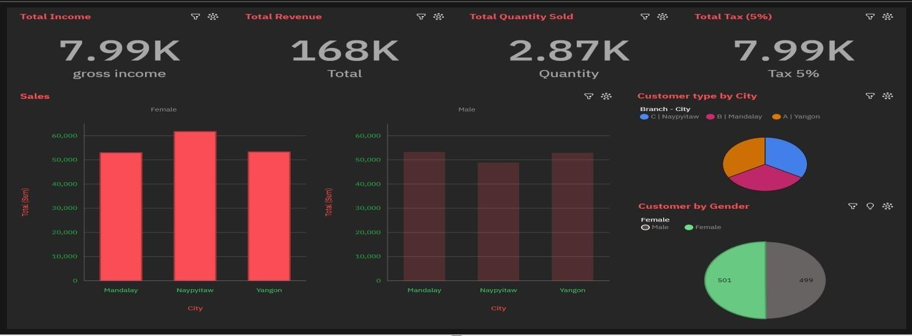

**Male Customers**

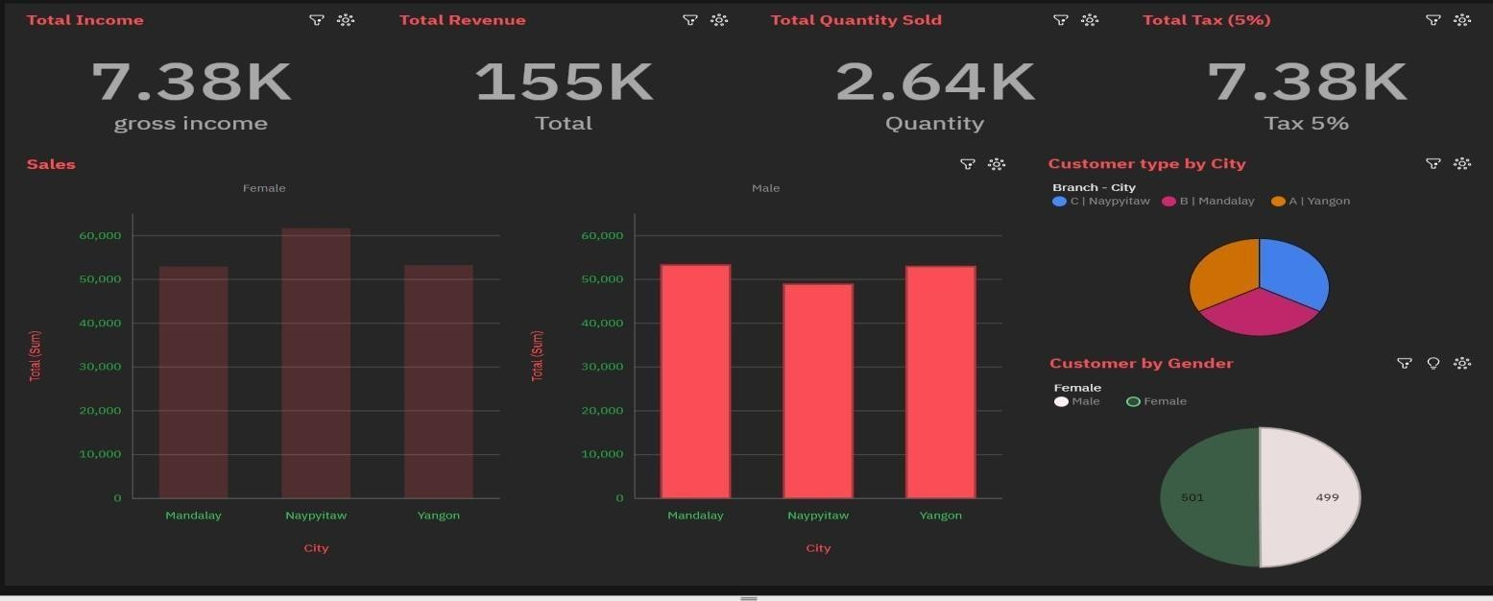

**Super Market – A - Naypyitaw**

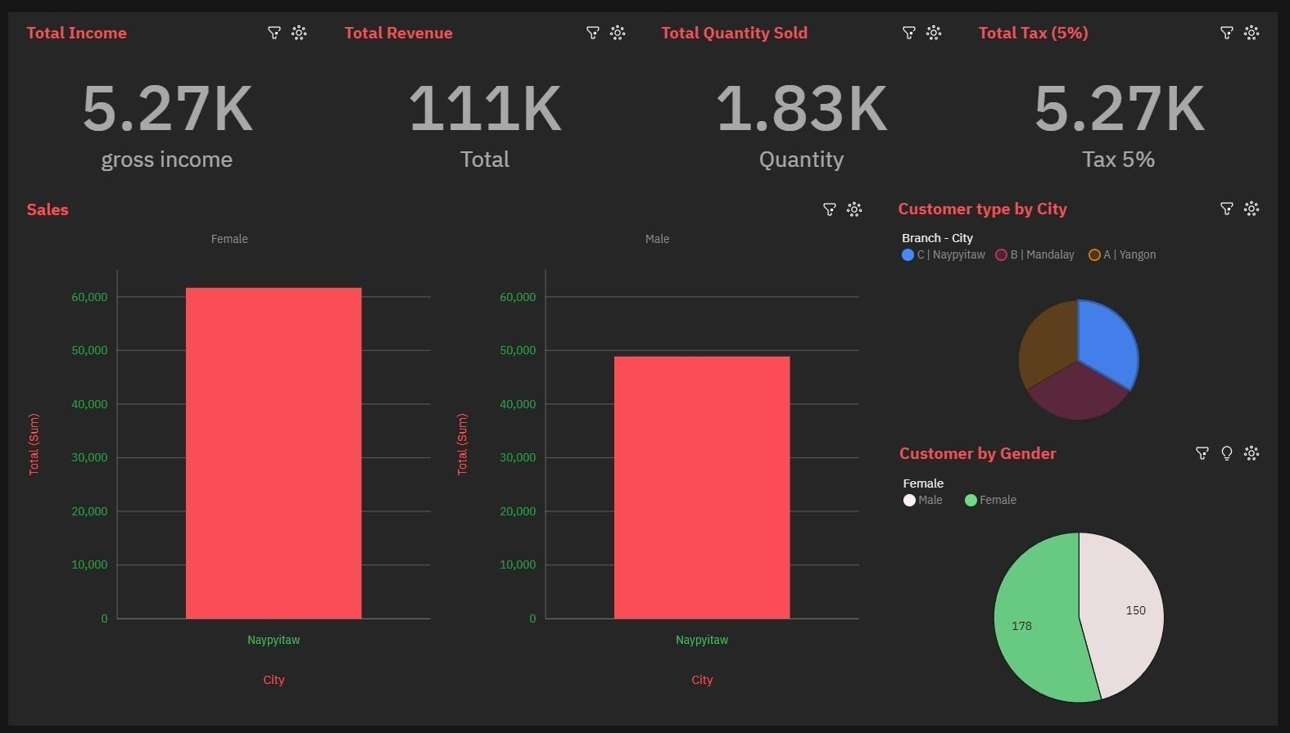

**Super Market – B - Yangon**

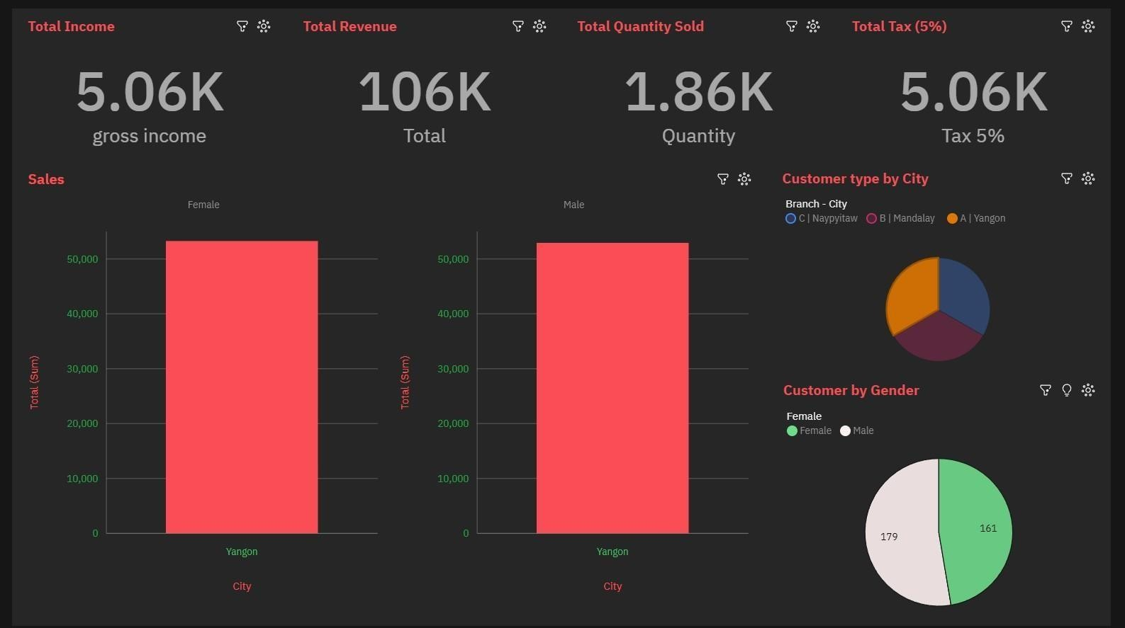

**Super Market – C- Mandalay**

